CREATING PRACTICE AND GAME SCHEDULES:

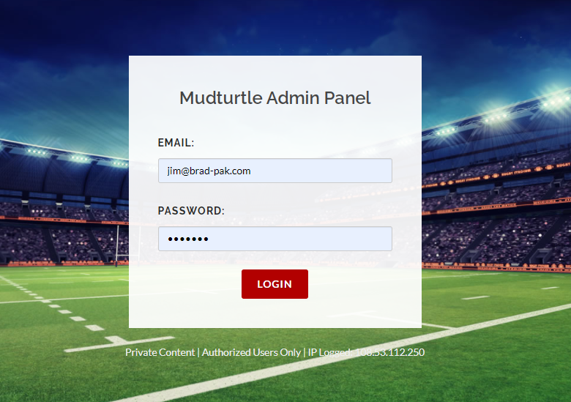

LOG INTO YOUR ADMIN ACCOUNT

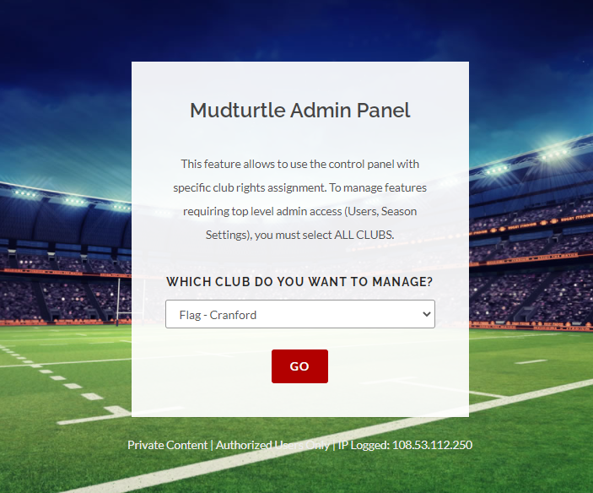

SELECT YOUR PROGRAM

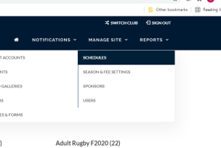

UNDER “MANAGER SITE” CLICK “SCHEDULES”

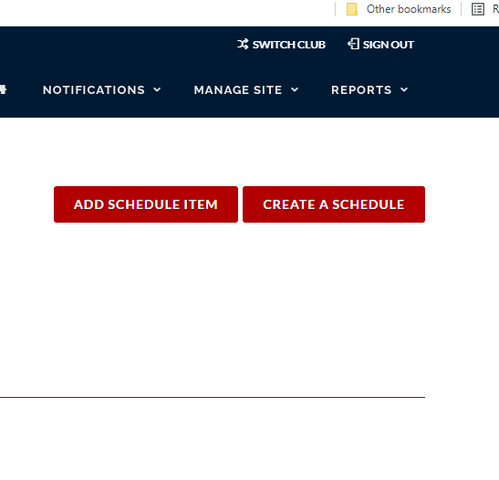
CLICK “ADD SCHEDULE ITEM”

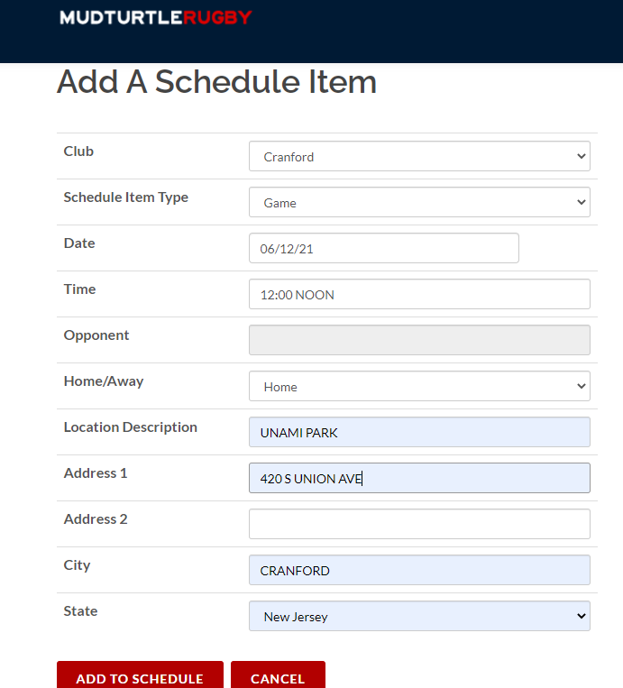

FOR GAMES CHOOSE “GAME”

FILL IN DATE, TIME, OPPONENT (NOT AN OPTION FOR FLAG) LOCATION, AND ADDRESS OF LOCATION.

PLEASE NOTE ADDRESS FOR LOCATION IS IMPORTANT, WHEN ADDRESS IS GIVEN IT BECOMES A LIVE LINK TO GOOGLE MAPS FOR THAT LOCATION ON THE WEBSITE. THIS MEANS FOR DIRECTIONS YOU CAN INSTRUCT PLAYERS AND PARENT TO CLICK ON THE LOCATION ON THE SCHEDULE.

ONCE IS ALL FILLED IN CLICK ADD TO SCHEDULE.
ONLY CLICK ONCE AND WAIT FOR SAVE COMPLETE MESSAGE.

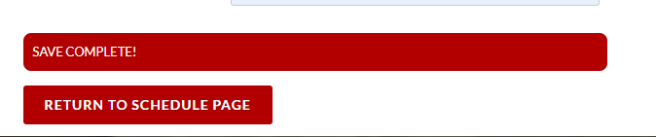

ONCE SAVED CAN RETURN TO SCHEDULE PAGE TO ADD MORE GAMES.
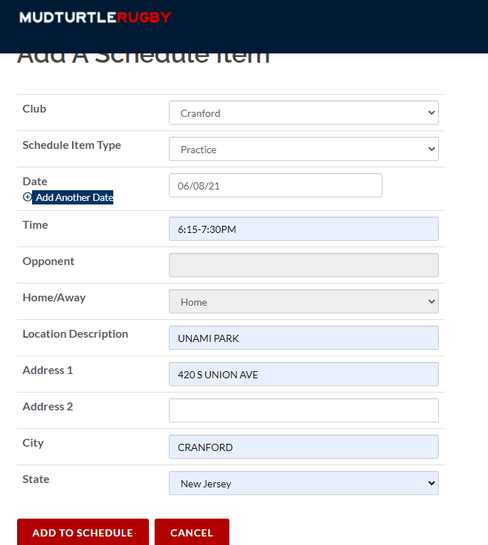

FOR PRACTICES CHOSE” PRACTICE”

FILL IN DATE, LOCATION, ADDRESS.

THEN CLICK “ ADD ANOTHER DATE”

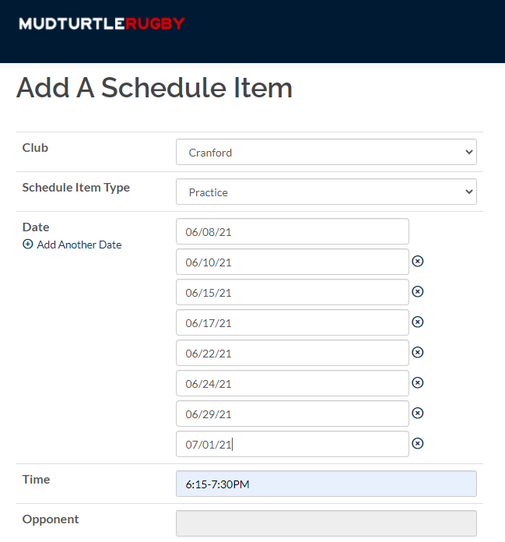

ENTER NEW DATE.

CONTINUE TO “ADD ANOTHER DATE” TILL DONE.

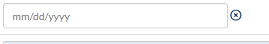
DO NOT LEAVE BLANK DATE AS THIS WILL KEEP SCHEDULE FROM POSTING.
CLICK ON “X” TO DELETE BLANK DATE

CLICK ADD TO SCHEDULE ONLY CLICK ONCE AND WAIT FOR SAVE COMPLETE MESSAGE.

TO EDIT CHANGE OR DELETE ANY SCHEDULE ITEM LOG INTO YOU ADMIN ACCOUNT

UNDER “MANAGER SITE” CLICK “SCHEDULES”

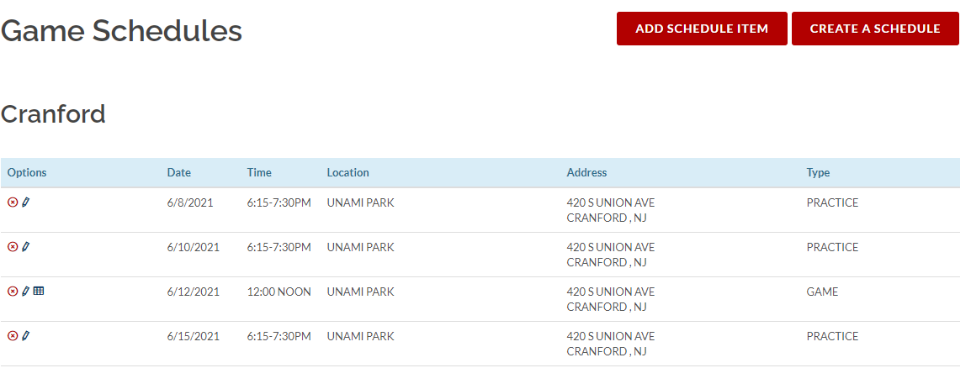

CLICK ON PENCIL ICON TO EDIT A SCHEDULED ITEM

CLICK ON RED “X” TO DELETE SCHEDULED ITEM

